

**GROUP 1**

**1.**Phoebe Chebet – BTCES/2023/50283

**2.**John Mwaura – BTCES/2022/51307

**3.**Daniel Kadhura – BTCES/2022/36366

**4.**David Abuga – BTCES/2022/51488

**GITHUB LINK**

<https://github.com/davidabuga/Library-management-system.git>

**SCREENSHOTS OF THE FEATURES OF THE APP.**

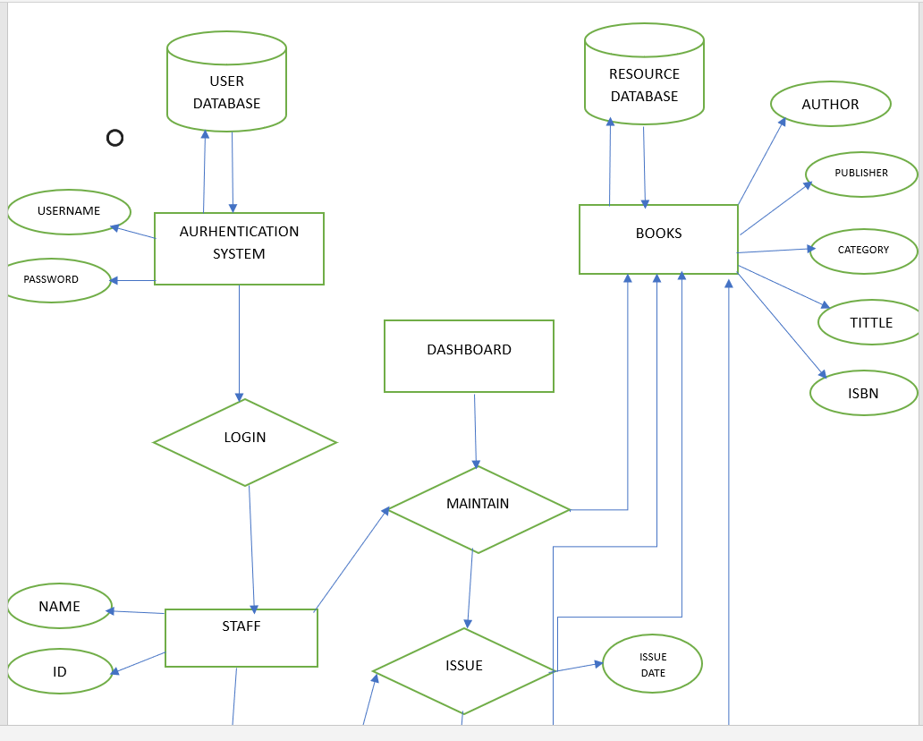

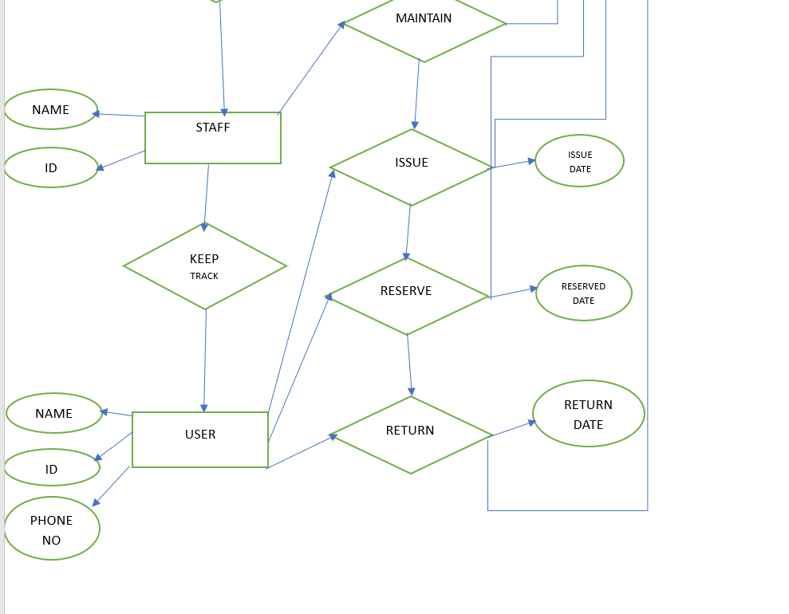

**THE FRONT END VIEW**

1. These screens show the dashboard in order to inform the user of the number of books and the dashboard of all the users. But only the admin haS the possibility to edit the users.
2. 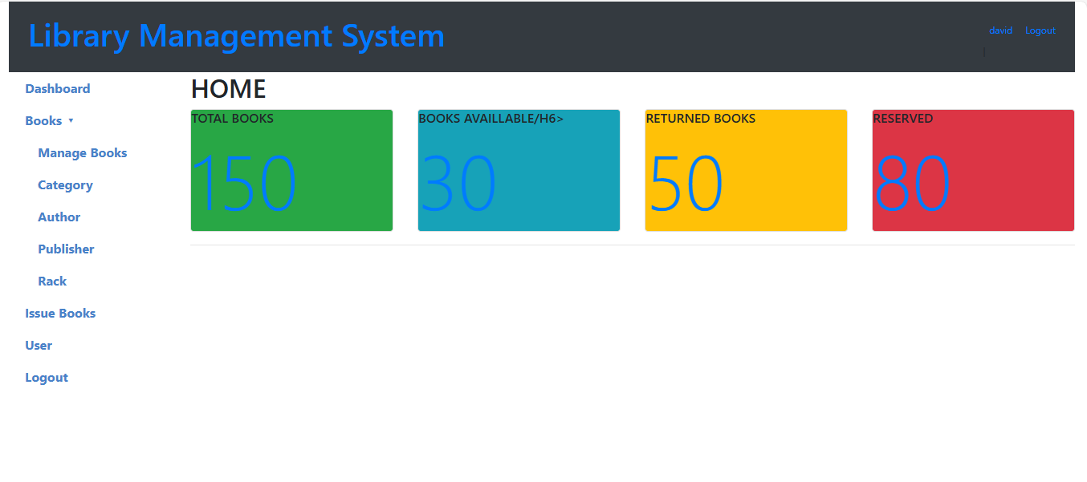

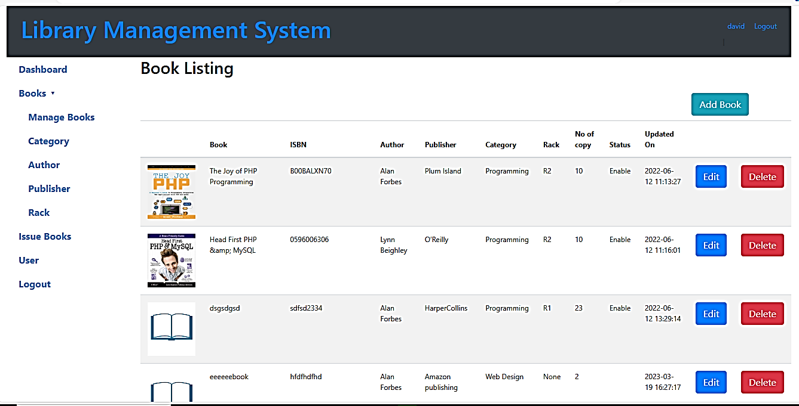

This screen shows the list of the authors and the admin has the possibility to change the name of the author.

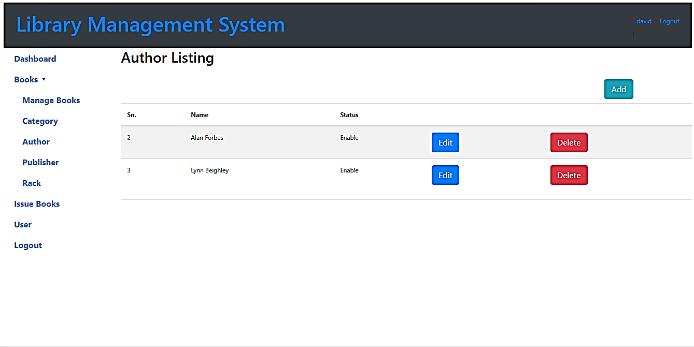

These screens show the book management system. The admin can delete a book and even edit the title of the book if this one needs to be changed.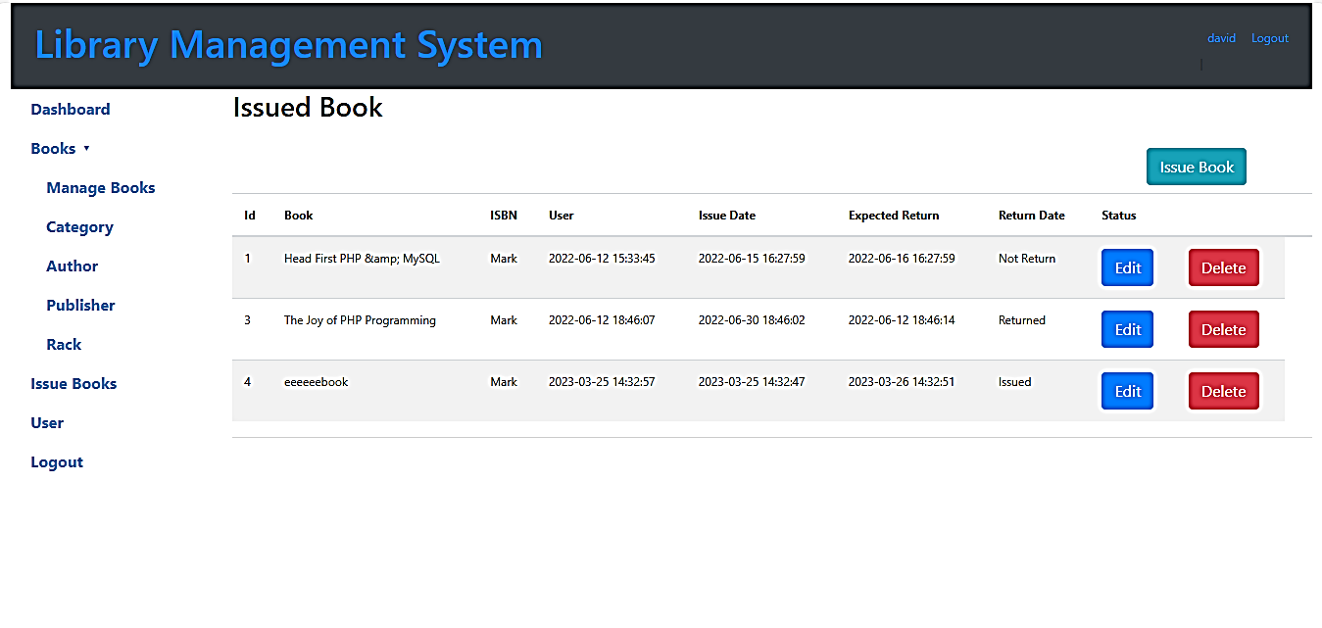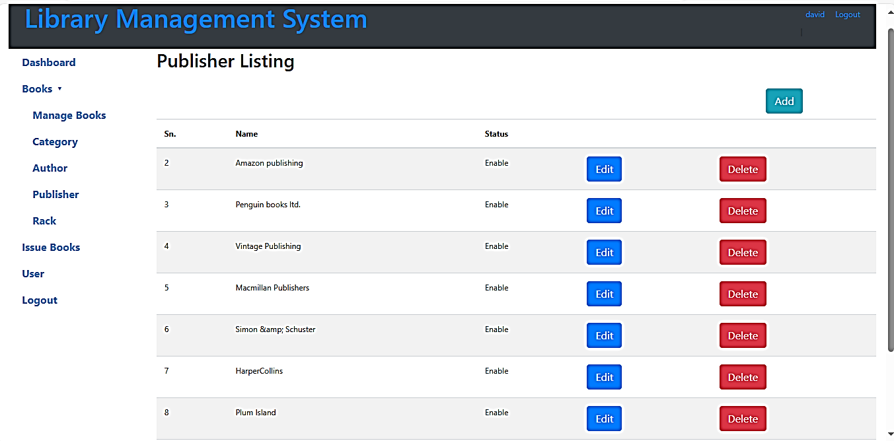

This screen shows the number of the users of the library. From here, the administrator can change a password of the users and edit the profile. This access to the users system is only for the admin and only the admin can change the informations.